Mariam Aoune and Maloney Khim

CART 263

Playful Interaction Project

Playtest Results

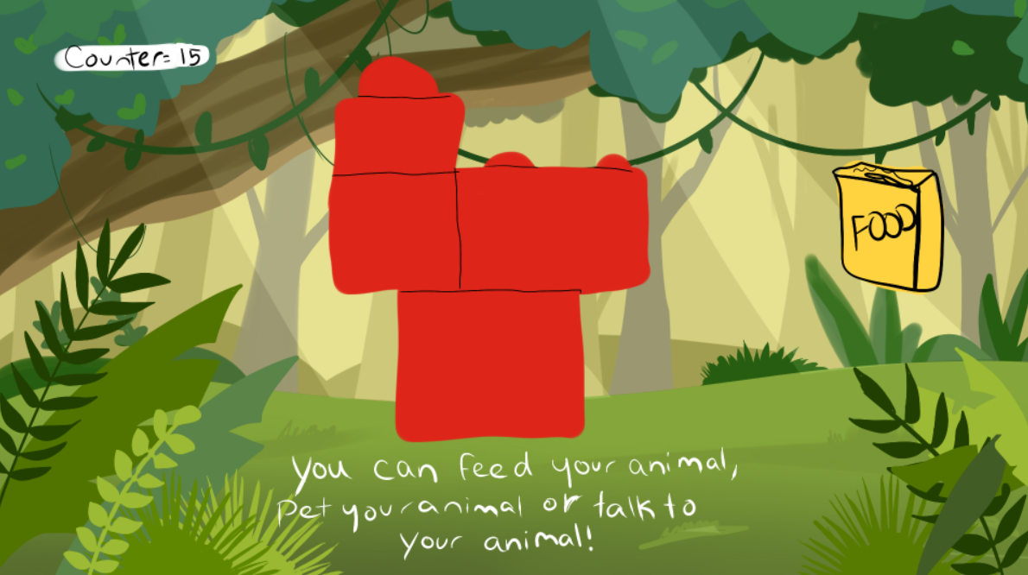

Figure 1 - Preliminary Sketch, this is a project where we build an animal with Lego blocks, take a picture of it and interact with it digitally on the computer.

* Add a physical prop of the background in cardboard or colored paper.
* Put black tapes on the edges of the Lego blocks to differentiate the pieces.
* Define the head of the animal somehow, use different color of Lego blocks for the head, or add some eyes and mouth (could be physical or digital)
* Have an egg that cracks open, could be loading page while the pixel of the picture are being read?
* What is the goal/meaning of the playful interaction? Is it like Tamagotchi? Is it about taking care of the pet? Collecting pets? The curiosity of the kid? Something else?
* What is the focus in this project, the physical part of building our pet with Legos blocks or interacting with the pet digitally on the computer with p5js?
* Possibility of limiting the number of animals we can build.
* Possibility of computer/AI recognition of the animal created with the Lego shapes?
* What more options we can add to the game to make it more interactive? Assign a name to the pet might be a good idea?
* Can we collect the animals like a pokedex, have a gallery of pictures of the pets?
* Maybe add some googly eyes or some stickers on the Lego blocks to make it look more alive?